April Newsletter

Dear families, what a busy month we have had! With learning about rainbows, birds, and weather, having time off for spring break and snow days! Thank you for taking time to come to your conference to talk about your wonderful children, I loved seeing everyone! With April we will delve into the life cycle of chicks, farm animals, and earth day. Please take note of the following information and important dates:

* I will be out from April 2nd to April 7th. As most of you know I am getting married this Friday! Mr. Zach and Ms. Skylar will be helping the classroom run smoothly well I am gone.
* Fundraiser with Licorice International on April 12th from 10 am to 5 pm. See office notes for more information.
* No school April 18th and April 21st
* Earth Day April 22nd

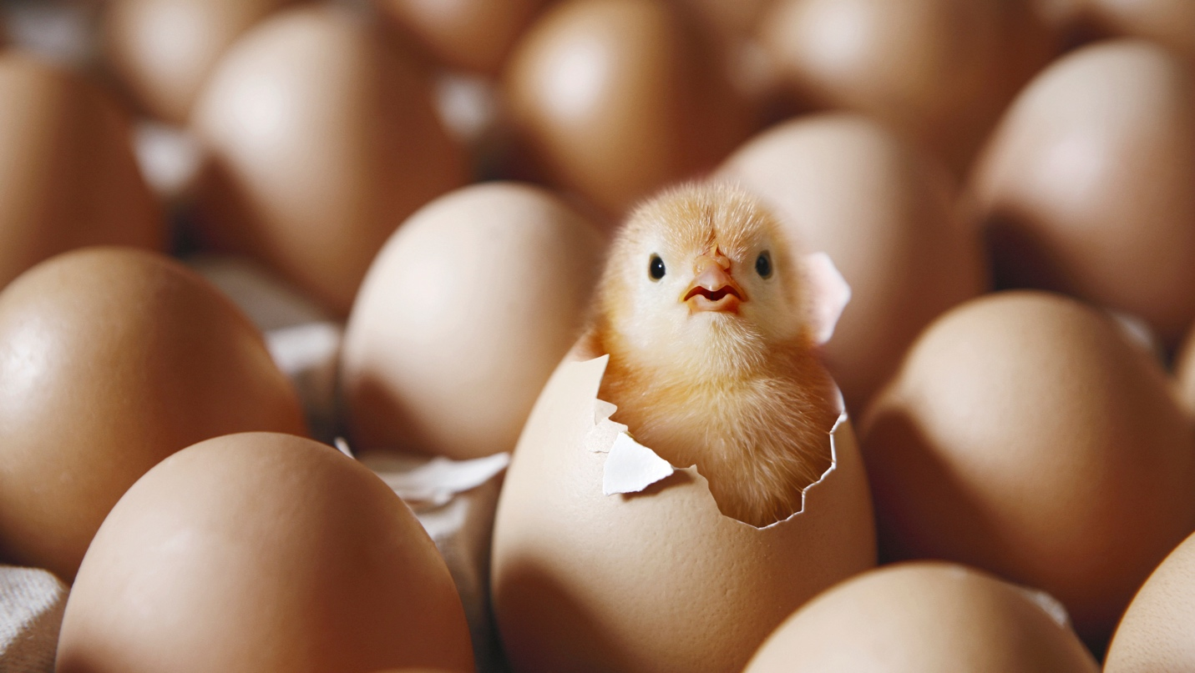

As I am sure you have heard the exciting news from your children, we got our eggs this month! I am hoping to see them hatch before April 11th. The children have been wonderful helpers with turning the eggs each day and being careful around the incubator. I can’t wait to see our baby chicks hatch and to hear their chirps!

How to help your child at home:

* Practice counting, number recognition, letter recognition, and the corresponding sounds.
* Practice writing their names and recognizing their names.